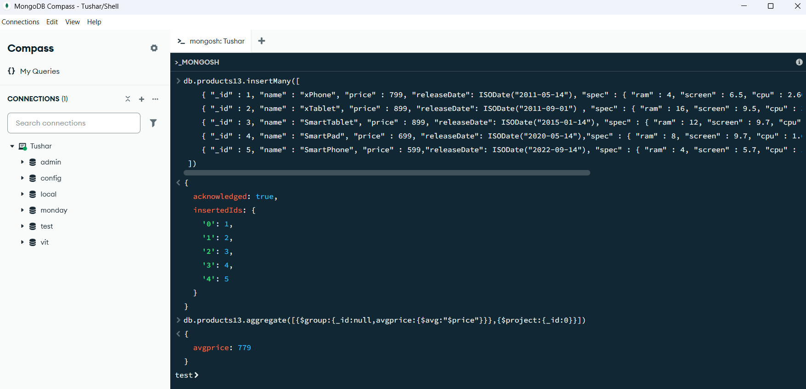

MongoDatabase database = mongoClient.getDatabase("vit");

MongoCollection<Document> collection = database.getCollection("products");

Document priceRangeQuery = new Document("price", new Document("$gte", 700).append("$lte", 900));

FindIterable<Document> products = collection.find(priceRangeQuery);

int totalPrice = 0;

int count = 0 ;

for (Document doc : collection.find()) {

Integer price = doc.getInteger("price");

if (price != null) {

totalPrice += price;

count ++ ; } }

System.out.println("Average Price: " + totalPrice/count);

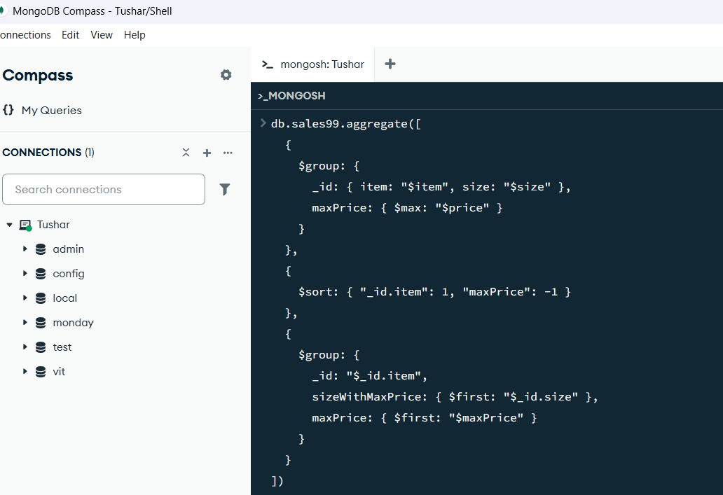

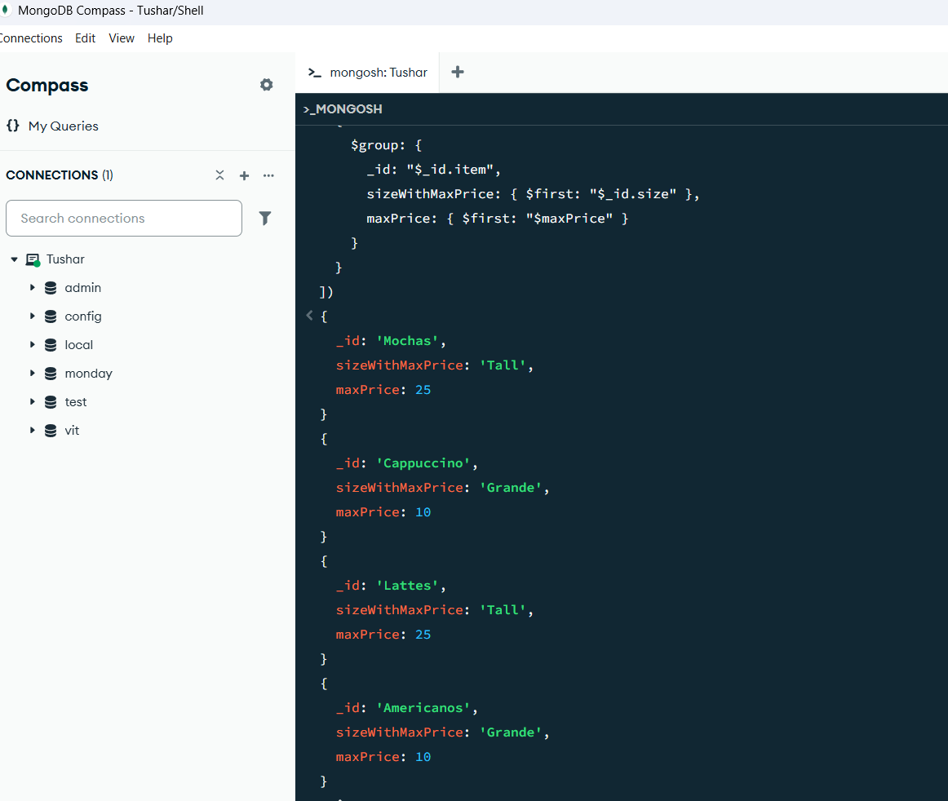

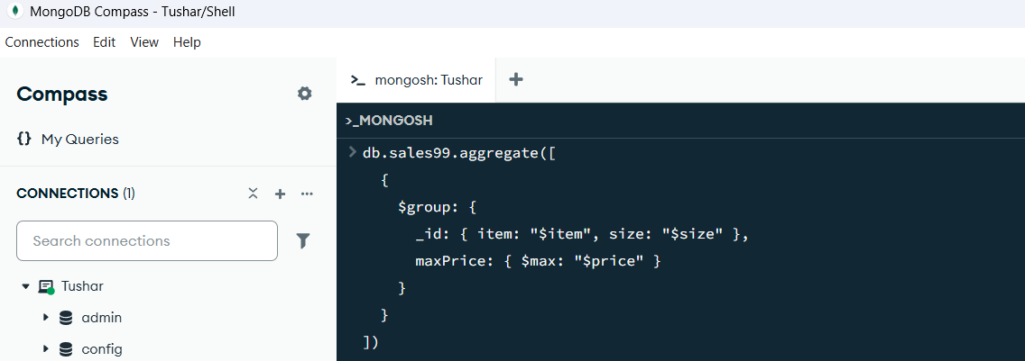

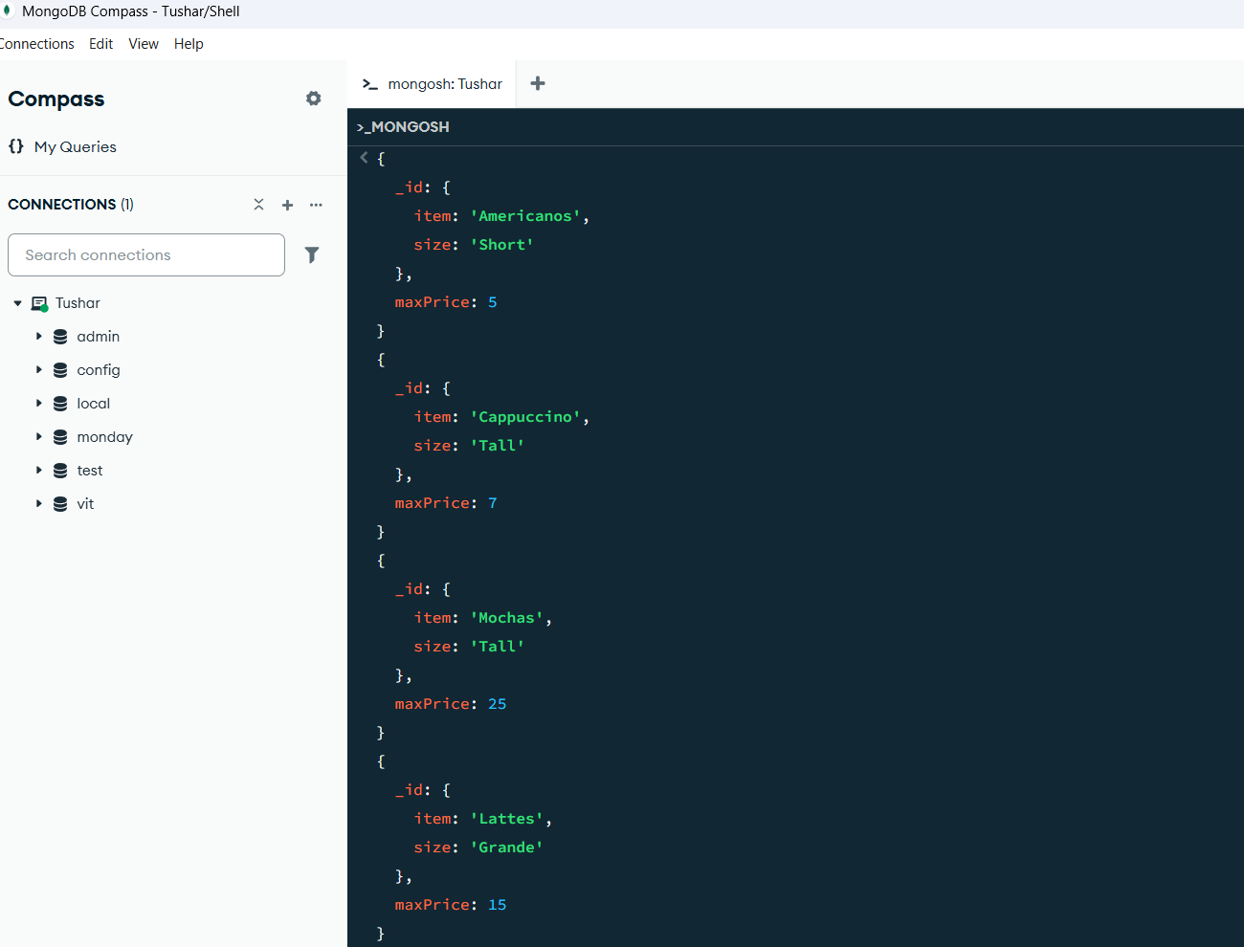

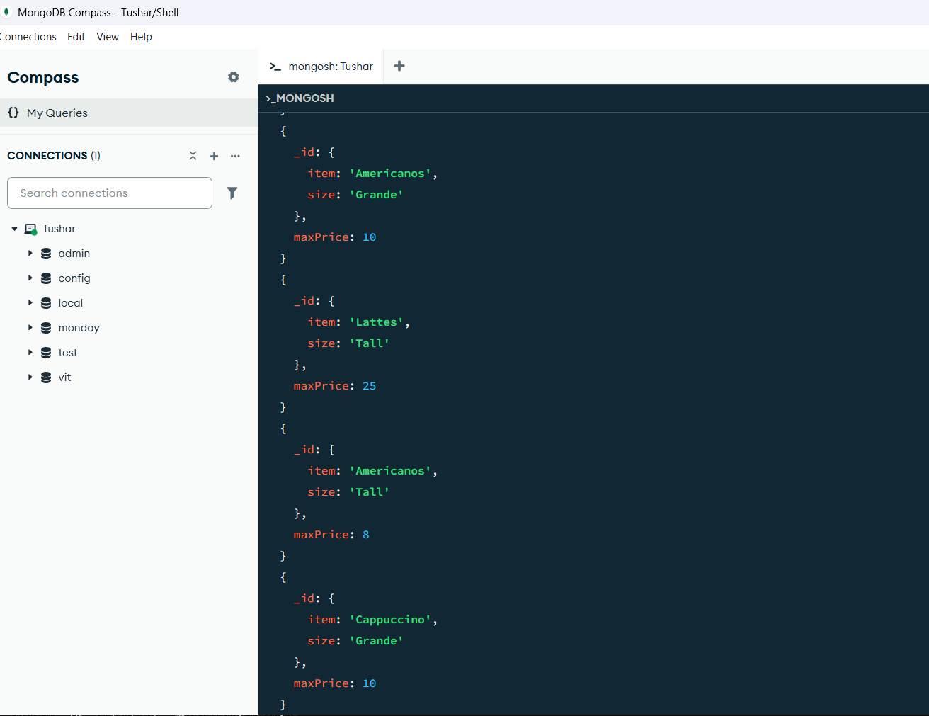

package connection;

import org.bson.Document;

import com.mongodb.client.MongoClient;

import com.mongodb.client.MongoClients;

import com.mongodb.client.MongoCollection;

import com.mongodb.client.MongoDatabase;

import static com.mongodb.client.model.Aggregates.*;

import static com.mongodb.client.model.Accumulators.*;

import static com.mongodb.client.model.Sorts.*;

import java.util.Arrays;

public class MongoDB {

public static void main(String[] args) {

try (MongoClient mongo = MongoClients.create("mongodb://localhost:27017")) {

MongoDatabase db = mongo.getDatabase("vit");

MongoCollection<Document> sales = db.getCollection("sales");

sales.aggregate(Arrays.asList(

group("$item",

max("maxPrice", "$price"),

addToSet("sizes", "$size")

),

sort(descending("maxPrice"))

)).forEach((Document doc) -> {

System.out.printf("%-10s: $%2d (Sizes: %s)%n",

doc.getString("_id"),

doc.getInteger("maxPrice"),

doc.getList("sizes", String.class));

});

}

}

}